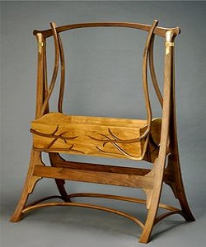

Baby cradle furniture

$19.60

Avilability: In stock

Description

Laying in the Lullaby Crib calms your newborn and swings your baby to sleep. Quite a comfortable way to get used to the world! Handmade Wood cradle. We choose to let our little ones sleep on sheepski. The comfortable cushioning of the headboard gives your baby body all the support needed to sit and relax. Available in multiple colors and sizes.Solid wood have inherent natural colors and variations that present a number of beautiful possibilities for your room.Our wood come in a wide range of stylish variations, including cherry, hickory, maple, birch and red oak.